Why Baydel For ClearCase

Executive Overview
Baydel is focused on improving ClearCase. Baydel has invested the significant resources to test & integrate various components to achieve the “Best of Breed” configuration for the ClearCase application. Reap the benefits from the investments Baydel has made so that your organization can avoid over-investing in hardware & manpower.

Baydel is focused on improving ClearCase in the following areas:

Availability: Superior VOB Data Integrity and Uptime
- improve data integrity on the VOB
- improve overall hardware up-time

- Performance: Improve Performance For The Following ClearCase Functions:
- Label
- Build
- Administrative: (scrubber, reformat VOB, etc.)

- Cost Effectiveness:
Reduce total cost of ownership. Properly size and configure the VOB server to increase performance and significantly reduce cost.
Baydel has tested the effects of:
- UFS vs. a journaling file system
- Cached RAID vs. non cached/intelligent subsystems
- Multi-processor CPU’s vs. single higher performance processors.

RESULT: Baydel can demonstrate that faster processor speed (as opposed to more processors) combined with a high end cached RAID sub-system, and a journaled file system will yield higher performance with cost savings.

Detailed Overview
Availability: Superior VOB Data Integrity
The Sun Storage Architectures rely on a single drive for accurate data integrity when all drives are functioning. If that drive sends back inaccurate data, data corruption will result. The Baydel however, requires all member drives to “vote” on the Integrity of the data, prior to passing data onto the VOB, thereby protecting one from a single drive passing erroneous data.

To verify that the Sun StorEdge architectures rely on a single device for data integrity, a single drive was removed from the StorEdge A1000, data blocks were overwritten, then the drive was replaced into the StorEdge A1000. Ideally, the storage subsystem should detect the inaccurate drive data. Undetected corruption increases risk and downtime to restore the VOB.

RESULT: the STOREDGE A1000 detected No corruption. This would lead to corrupt data being sent back to the VOB. Specific Details on this test are noted in Attachment A.

To simplify the explanation of the data integrity test, in the diagram below, drive number 3 was removed from the A1000, data = 3 was changed to data = 6, the drive was then replaced into the A1000. The A1000 did not detect the corruption and passed back the corrupt data. The same test on the Baydel architecture yields a “check error” on the raid and a hard read error to the VOB, but corrupt data is not passed back to the VOB…Baydel will not corrupt the data.

The following diagram illustrates the fundamental architectural difference that provides Baydel with superior data integrity.
Availability: Superior VOB Data Uptime
The Baydel Architecture provides better resiliency features than the StorEdge
Architectures:

StorEdge A1000: The Baydel architecture has mirrored cache and a built in UPS that provides power to entire subsystem in the event of a power failure. The StorEdge A1000 has no mirrored cache capabilities, so a single SIMM failure can result in corrupt data and will result in downtime.

StorEdge T3: The Baydel architecture has mirrored cache and a built in UPS that provides power to entire subsystem in the event of a power failure. The StorEdge T3 has the ability to mirror the cache to another StorEdge T3 (but requires two StorEdge T3’s) and “There will be a performance impact when cache mirroring is enabled. This overhead is caused by the data being written to two separate controller caches.” (Sun StorEdge T3 Disk Tray Administrator’s Guide – July 2000 page 2-4) The Baydel architecture has no performance impact with mirrored cache.

Performance: Improve Performance on ClearCase

The following outlines the actual I/O profile for actual Production ClearCase operations
- Write Intensive (71.99% of operations are writes)
- Small (< 16K) transaction oriented I/O sizes

Production Data: ClearCase I/O profile from VxFS – Raidmon I/O Performance Data

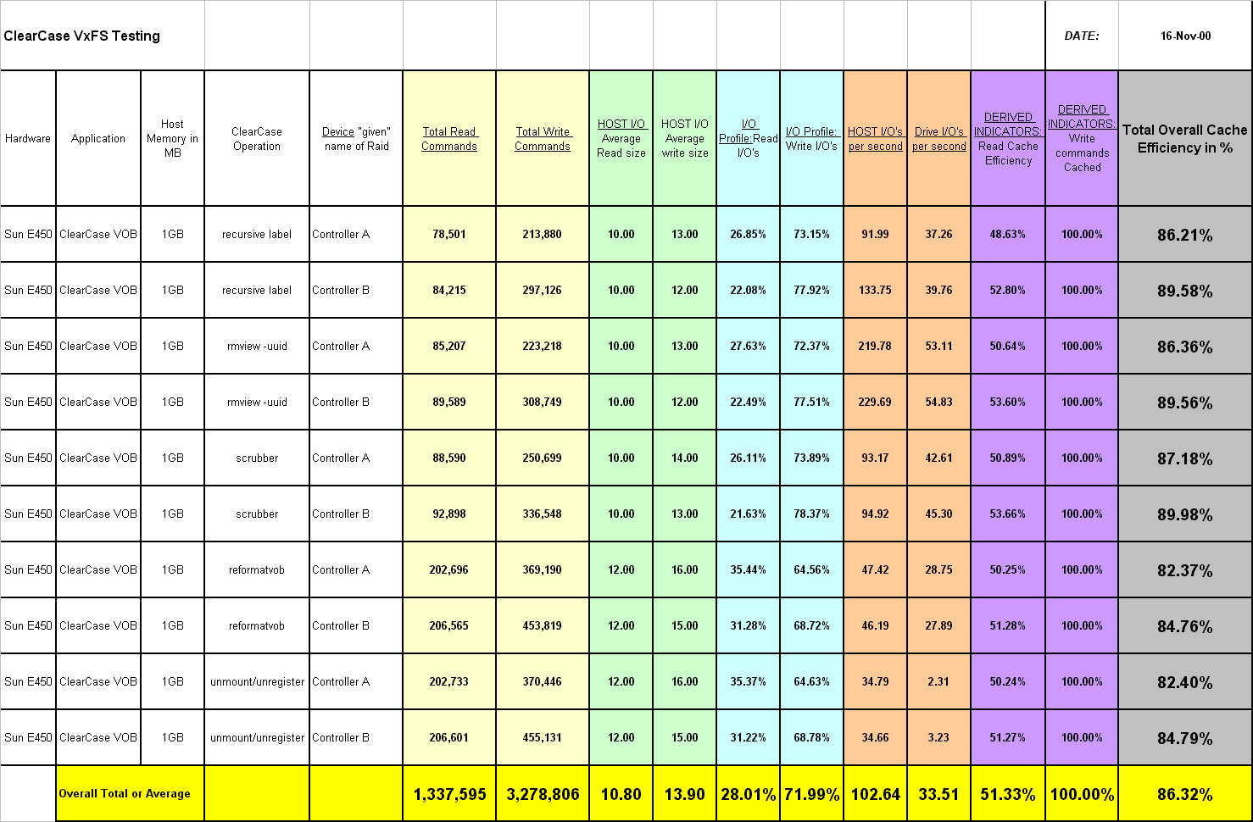

Actual ClearCase Performance Testing
Baydel set up an actual ClearCase VOB to understand and improve performance within a ClearCase environment. Tests were conducted using Rational’s ClearCase 4.1. The initial data set consisted of production ClearCase VOBs for actual customers. All the VOBs used ClearCase schema 54. Actual ClearCase operations were executed against the VOB server, then the data set was restored, one variable changed and test run to measure the impact of the changed variable.

Actual ClearCase Performance Testing
StorEdge A1000: Initial ClearCase testing was CPU bound, Baydel is in the process of setting up a configuration with faster CPU clock speeds to remove this bottleneck. The test results conclude that the Baydel architecture has more headroom (based on iostat)
StorEdge A1000 Average % busy = 33.67%
Baydel Average % busy = 20.78%

StorEdge T3: There is evidence that the StorEdge T3 is likely to perform worse than the StorEdge A1000 (for UFS filesystem due to writing of smaller indirect blocks) and worse than the Baydel (with either UFS or VxFS). The write characteristics of the StorEdge T3 were tested in a non-partner group configuration (no mirrored cache), note: write performance is likely to be worse in a partner group configuration. The following shows the write performance curves for the T3, A1000 and Baydel array. The shaded area represents the area on the performance curve that is indicative of the ClearCase application.

As illustrated earlier in the ClearCase I/O profile from VxFS – Raidmon I/O Performance Data: A ClearCase I/O profile is:

Average Read I/O size 10.8K

Average Write I/O size 13.9K

Percent of ClearCase I/O Operations – Writes 71.99%

The cached performance curves in this range are as follows:

Baydel OESR2000 Sun T3 (0+1) Sun A1000(0+1)

8K Write I/O’s 3555 2527 1978

16K Write I/O’s 2347 2044 1552

Baydel’s Response to Sun/Informix tests:
Sun is known to provide ClearCase users with ClearCase performance testing which was performed by Informix. Baydel has contends that the conclusions noted within this document are inaccurate. The Informix conclusions were based on a simulated ClearCase workload. Baydel has found that the simulated data used for the test was not indicative to an actual production workload. In order to reap accurate and meaningful data, one must use production data and the actual ClearCase application.

Informix testing was done with scripts written by Informix to simulate a ClearCase workload. Baydel testing was done on an actual VOB, configured with the ClearCase application, using actual customer workload and data. Bottom line: Simulated data/tests make assumptions that may or may not be indicative of an actual environment. If the assumptions are not accurate, inaccurate conclusions can be reached. All Baydel testing was performed using actual ClearCase workloads.

Simulated application tests can yield different results than actual ClearCase application tests. The conclusions of Informix simulation contradict actual ClearCase application tests using actual production data.

#1. Informix simulated testing found the UFS filesystem to be better.

Baydel measured elapsed times of actual ClearCase operations.
Findings: the VxFS filesystem clearly improves ClearCase performance:
% Improvement of VxFS over UFS - Label 19.79%
% Improvement of VxFS over UFS – All ClearCase Operations Tested 12.74%

#2. Informix simulated testing found that more CPU’s improved performance.

Baydel ran a controlled comparative test, utilizing actual customer production data.
Findings:
mpstat data during actual ClearCase operations show the lockmgr / db writer to be single threaded in nature. With more CPU’s, instructions are simply round robined to available CPU’s, but execute in a serial manner (as opposed to parallel). Individual VOB performance does not improve as CPU’s are added.

#3. Informix simulated testing found the StorEdge A1000 configured as Raid 5 was faster than the StorEdge A1000 configured as Raid 0+1.

Baydel ran a controlled comparative test, utilizing actual customer production data.
Findings:
In actual ClearCase operations, Raid 0+1 is faster than Raid 5

Step | Description | A1000 Raid 5 | A1000 Raid 0+1
1 | Reset Baydel Statistics | 00:14.0 | 00:14.0
2 | Labeling | 44:51.0 | 42:59.0
3 | rmview –uuid | 01:23.0 | 01:17.0
4 | Scrubber | 05:16.0 | 05:08.0
5 | Reformat | 59:20.0 | 54:51.0
6 | umount/unregister | 00:47.0 | 00:47.0
 | Total | 1:51:51 | 1:45:16

Note: These performance differences are likely to be even larger once the CPU clock speed bottleneck is removed.

Attachment A: Testing Data Corruption on the StorEdge A1000

copy .ps file multiple times to vxfs filesystem on A1000

perform diff on files...
/dev/vx/dsk/sundg1/vol01
20480 17800 2517 88% /sun_r10

# diff test test1
# diff test test2
# diff test test3
# diff test test4
# diff test test5
# diff test test6
# diff test test7
# diff test test8
# diff test test9

# ls -l
total 33380
-rwxr-xr-x 1 root other 1708494 Nov 16 20:06 test
-rwxr-xr-x 1 root other 1708494 Nov 16 20:06 test1
-rwxr-xr-x 1 root other 1708494 Nov 16 20:06 test2
-rwxr-xr-x 1 root other 1708494 Nov 16 20:06 test3
-rwxr-xr-x 1 root other 1708494 Nov 16 20:07 test4
-rwxr-xr-x 1 root other 1708494 Nov 16 20:07 test5
-rwxr-xr-x 1 root other 1708494 Nov 16 20:07 test6
-rwxr-xr-x 1 root other 1708494 Nov 16 20:07 test7
-rwxr-xr-x 1 root other 1708494 Nov 16 20:07 test8
-rwxr-xr-x 1 root other 1708494 Nov 16 20:07 test9

drive one was extracted and written to using a pc. It was then placed back in the a1000 and powered back up.

the diff now fails....

# diff test test5
15223,17511c15223,15758
< 0.1 (layout,) 206.02 605.43 S
< 0.1 (components,) 239.97 605.43 S
< 0.1 (and) 300.23 605.43 S
< 0.1 (pr) 319.99 605.43 S
< 0.1 (operties.) 329.97 605.43 S

format /analyze/read was also run. It detected no errors...

analyze> read
Ready to analyze (won't harm SunOS). This takes a long time,
But is interruptible with CTRL-C. Continue? y

pass 0
47/63/16

pass 1
47/63/16

Total of 0 defective blocks repaired.
analyze>

This was run on the StorEdge A1000 configured as both a raid 0 + 1 and a raid 5. both yielded corrupt data. Note that the A1000 failed to notify of any issue as it has no ability to detect corruption on a disk and therefore passes back bad data ! This does not occur on a Baydel, the Baydel will report a hard read error, but will not pass corrupt data to the VOB.

